Probe | Magnetical susceptibility at room temperature $$χ$$, $${10}^{-3}$$ | Magnetical susceptibility of frozen examples $$χ$$, $${10}^{-3}$$ | Ratio of value for frozen example to value at room temperature
1 | 3.46±0.14 | 2.62±0.20 | 0.757
2 | 3.15±0.17 | 2.38±0.20 | 0.756
3 | 3.24±0.12 | 2.41±0.20 | 0.744
4 | 4.45±0.39 | 2.71±0.32 | 0.609

In order to study the magnetic properties of the soil , four samples were taken along the profile to the east of the absolute hut with a step of 10 m. A layer of turf was removed with a shovel, then a layer of soil was taken from under it and placed in a plastic container, which was then placed in a plastic bag.

Magnetic susceptibility measurements were carried out using a Bartington MS2K magnetic susceptibility meter designed for surface measurements. During measurements, the sensor must be pressed against the surface of the sample and its magnetic susceptibility is determined by the field that occurs when the sample is magnetized. It is assumed that the effective volume inside which the measurement is made does not exceed 20 mm in thickness. To calibrate the device, a sample with a known magnetic susceptibility provided by the manufacturer is used, measurements on it showed a coincidence of values with an accuracy of up to 1%.

The sensor was pressed to the sample surface at different points along a square grid, with a step approximately equal to the sensor diameter. A single measurement consists of three stages: measurement in the air at a distance not closer than 2 cm from the sample, measurement in the pressed state, repeated measurement in the air. Each stage lasts about 10 seconds. 15 measurements were carried out for each sample, the average value and the error of the average were calculated based on their results. The measurement results are shown in the table.

In general, the soil can be characterized as magnetic: with a vertical component of 46 µT, the induced field will be 150 nT, therefore, the presence of pits, traces of trenches (in which the soil is decompressed) should lead to noticeable magnetic anomalies with an amplitude of tens of NT. In order to verify this position, it was decided to conduct an experiment to measure the magnetic field before and after digging a hole in the soil. along the way, it was proposed to take soil samples at different depths, because it was assumed that the magnetic susceptibility may vary with depth.

As a point for the experiment, it was decided to choose the place where the third sample was taken (35 m from the pavilion), since the values of the susceptibility of the soil in it were intermediate between the others.

On 26-27.06.2023, with the help of GSM-19W, surveys were carried out at a height of 0.15 and 1 m - an area of 4 by 4 m with the center at the place where the third sample was taken in increments of 1 m. GSM-19 was used as a reference variometer. The survey revealed a rather strong heterogeneity of the field - about 50 NT at the soil surface, about 25 NT at a height of 1 m.
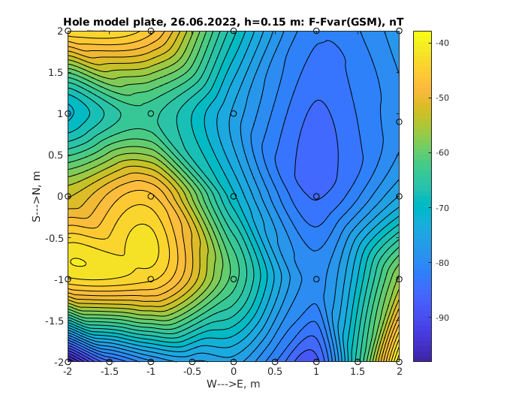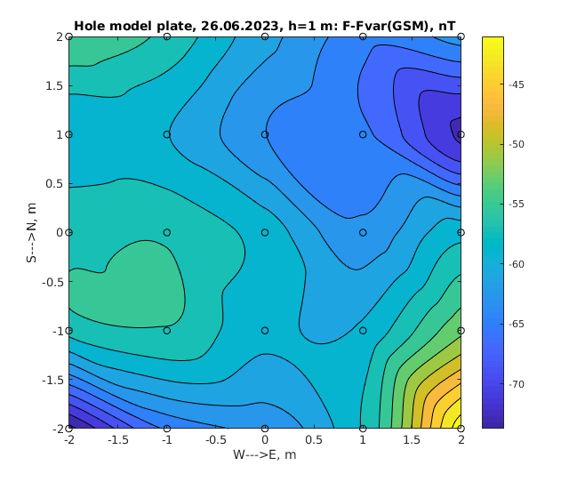

Рисунок 2. The distribution of the field module on the site around the third sample on 26-27.06.2023 at a height of 0.15 m and 1 m. The circles show the measurement locations.

On 27-28.06.2023, a pit was dug at the place where the third sample was taken (35 m east of the absolute pavilion). The depth is 1m, 0.8 by 1 m in the horizontal plane. In the upper part of the section there is soil, then sand, after the gray interlayer there is an ochre layer, after the pebble interlayer there is clay, in places there are stones in it. Soil samples were taken at depths of about 20, 40, 60, 80, 100 cm.

On 06/28/2023, a survey was carried out at a height of 1m of the area around the pit (Khomutov, Gvozdarev) according to the previously developed methodology.

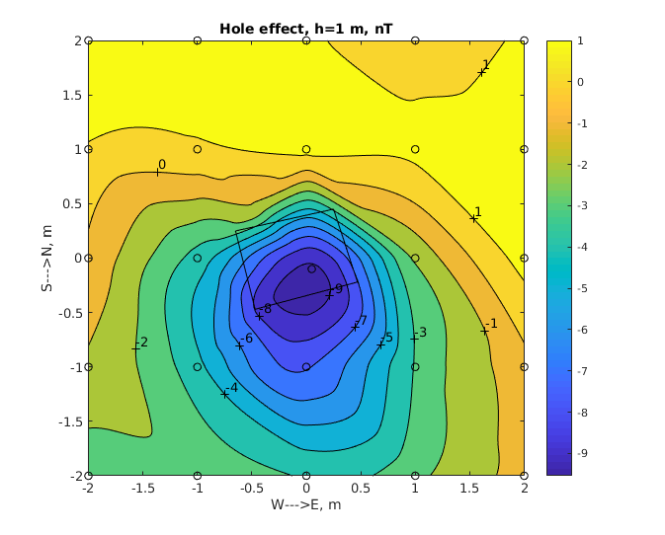
Figure - Distribution of the difference in the total field before and after digging the pit.

The difference of surveys at a height of 1m before and after digging the pit revealed a change in the field by +1 /-10 nT. The positive anomaly is located to the north of the pit, the negative one to the south with the center on the southern edge of the pit. The nature of the anomaly generally corresponds to the predictions of the model, but indicates a much smaller magnitude of the magnetic susceptibility of the soil than in the 3rd sample (about 6 times). Figure 6 shows the calculated distribution of the field modulus at a height of 1m, created by a pit with a depth of 1m measuring 0.9 by 0.9 m in soil with a magnetic susceptibility of 0.0005. In general, the picture is similar to that observed in measurements: to the north there is a region of positive values of the anomalous field modulus, the extremum of the anomaly is shifted to the region of the southern edge of the pit.
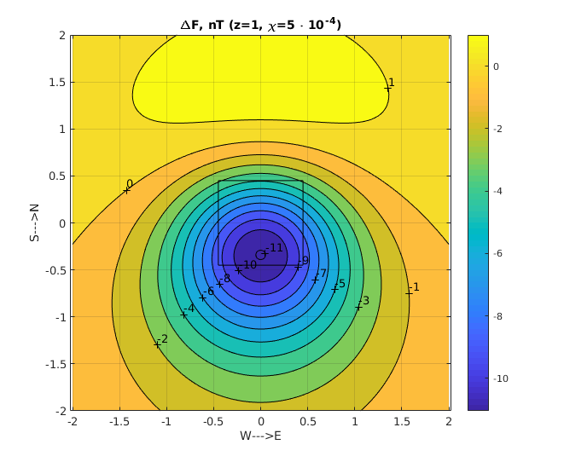
Figure - The calculated distribution of the field modulus at a height of 1m, created by a pit with a depth of 1m measuring 0.9 by 0.9 m in soil with a magnetic susceptibility of 0.0005

Эффекты влияния температуры на магнитную восприимчивость грунта
To study the effect of temperature on the magnetic susceptibility of the soil, soil samples were frozen in a freezer. Samples were brought from it and placed on the street, where the temperature was already negative in the morning (measurements were carried out in October). Then they were brought into the building one by one and magnetic susceptibility measurements were carried out. The temperature was controlled by a thermometer placed in a recess in the sample, which was made with a copper nail. Particular attention was paid to the density of the sensor's contact with the sample — the sensor was placed in wells from past measurements that retained their shape, in the presence of litter (grains of sand, ice), it was removed from the hole. As can be seen from it, the measurements in three samples are 74-75% of the magnetic susceptibility at room temperature. Such a coincidence, apparently, can be considered as evidence that efforts to ensure the tightness of the samples to the sensor have borne fruit.

As can be seen from the table, the measurements show that the surface layer significantly loses its magnetic susceptibility during freezing. Apparently, this is due to the effects of soil decompression during freezing, but this decrease itself is too high, since even for ice, the density changes by only 10%. In soils, the decompression is usually of the order of 1% - accordingly, we can expect a change in magnetic susceptibility to similar values. The reasons for such strong changes are not entirely clear.

Nevertheless, our experiments indicate a decrease in the magnetic susceptibility of the soil when it freezes. In the case of soil cooling in winter, this should lead to the formation of a "demagnetized" layer of soil that has passed through the freezing point. If the freezing occurs inhomogeneously, for example, due to differences in the thickness of the snow cover at different points (under the pavilion, the snow layer is usually thinner), this can lead to the formation of a horizontal gradient of soil magnetization and the appearance of a field gradient that will depend on the temperature of the soil.

- E. Tamm Fundamentals Of The Theory Of Electricity . - Moscow: Mir Publishers,1979. - 695 p.

